**Nuclear Weapons Tests (U.S.)**

(Los Alamos National Laboratory Database) Original images have been digitized in color.

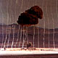

**Able**

1kt, Nevada Test Site, 27.Jan.1951 or 1.Apr.1952

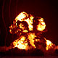

**Annie 1**

16kt, Nevada Test Site, 17.Mar.1953

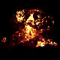

**Annie 2**

16kt, Nevada Test Site, 17.Mar.1953

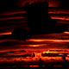

**Apache**

1.9Mt, Eniwetok, 8.Jul.1956

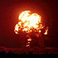

**Apple**

14kt, Nevada Test Site, 29.Mar.1955

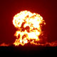

**Apple II**

29kt, Nevada Test Site, 5.May.1955

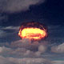

**Arkansas**

Low 1Mt, Christmas Island, 2.May.1962

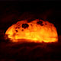

**Aztec**

20kt-1Mt, Christmas Island, 27.Apr.1962

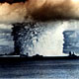

**Baker**

21kt, Bikini, 24.Jul.1946

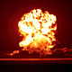

**Bee**

8kt, Nevada Test Site, 22.Mar.1955

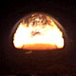

**Bighorn**

>1M, Christmas Island, 27.Jun.1962

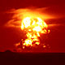

**Blackfoot**

8.5kt, Eniwetok, 11.Jun.1956

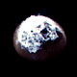

**Bluegill**

<1Mt, Johnston Island, 26.Oct.1962

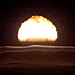

**Bluestone 1**

>1Mt, Christmas Island, 30.Jun.1962

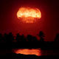

**Bluestone 2**

>1Mt, Christmas Island, 30.Jun.1962

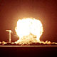

**Blotzman**

12kt, Nevada Test Site, 28.May.1957

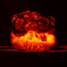

**Bravo**

15Mt, Bikini, 28.Feb.1954

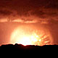

**Cactus**

18kt, Eniwetok, 5.May.1958

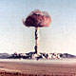

**C**

"Buster Charlie", 14kt, Nevada Test Site, 30.Oct.1951

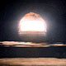

**Chama**

>1Mt, Johnston Island, 18.Oct.1962

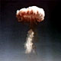

**Charlie 1**

14kt, Nevada Test Site, 30.Oct.1951

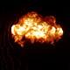

**Charlie 2**

31kt, Nevada Test Site, 22.Apr.1952

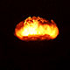

**Chetko**

20kt-1Mt, Christmas Island, 19.May.1962

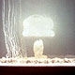

**Climax**

61kt, Nevada Test Site, 4.Jun.1953

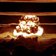

**Dakota**

1Mt, Bikini, 25.Jun.1956

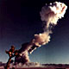

**D**

"Buster Dog," 21kt, Nevada Test Site, 1.Nov.1951

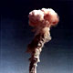

**Dog 1**

21kt, Nevada Test Site, 1.Nov.1951

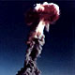

**Dog 2**

19kt, Nevada Test Site, 1.May.1951

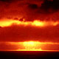

**Dog 3**

19kt, Nevada Test Site, 1.May.1951

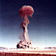

**E**

"Buster Easy," 31kt, Nevada Test Site, 5.Nov.1951

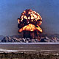

**Fizeau 1**

11kt, Nevada Test Site, 14.Sep.1957

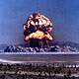

**Fizeau 2**

11kt, Nevada Test Site, 14.Sep.1957

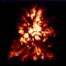

**Fox**

11kt, Nevada Test Site, 25.May.1952

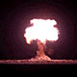

**Franklin**

4.7kt, Nevada Test Site, 30.Aug.1957

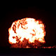

**Galileo**

11kt, Nevada Test Site, 2.Sep.1957

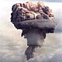

**George**

225kt, Nevada Test Site, 8.May, 1951

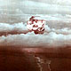

**George**

15kt, Nevada Test Site, 1.Jun.1952

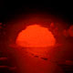

**Greenhouse**

??, Eniwetok, 1951

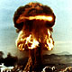

**Grable**

15kt, Nevada Test Site, 25.May.1953

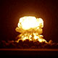

**Harry**

32kt, Nevada Test Site, 19.May.1953

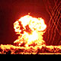

**Hornet**

4kt, Nevada Test Site, 12.Mar.1955

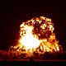

**How**

14kt, Nevada Test Site, 5.Jun.1952

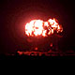

**Kepler**

10kt, Nevada Test Site, 24.Jul.1957

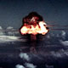

**King**

500kt, Eniwetok, 15.Nov.1952

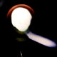

**Kingfish**

<1Mt, Johnston Island, 1.Nov.1962

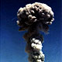

**Met**

22kt, Nevada Test Site, 15.Apr.1955

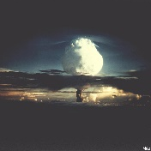

**Mike**

10.4Mt, Eniwetok, 31.Oct.1952

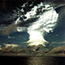

**Mike**

10.4Mt, Eniwetok, 31.Oct.1952

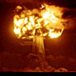

**Mohawk**

350kt, Eniwetok, 2.Jul.1956

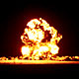

**Moth**

2kt, Nevada Test Site, 22.Feb.1955

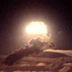

**Nambe**

20kt-1Mt, Christmas Island, 27.May.1962

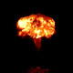

**Newton**

12kt, Nevada Test Site, 16.Sep.1957

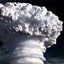

**Oak**

8.9Mt, Eniwetok, 28.Jun.1958

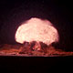

**Santa Fe**

1.3kt, Nevada Test Site, 30.Oct.1958

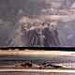

**Seminole**

13.7kt, Eniwetok, 6.Jun.1956

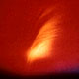

**Starfish 1**

1.4Mt, Johnston Island, 9.Jul.1962

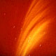

**Starfish 2**

1.4Mt, Johnston Island, 9.Jul.1962

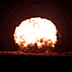

**Shasta**

17kt, Nevada Test Site, 18.Aug.1957

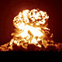

**Simon**

17kt, Nevada Test Site, 18.Aug.1957

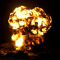

**Smokey**

44kt, Nevada Test Site, 31.Aug.1957

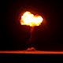

**Socorro**

6kt, Nevada Test Site, 22.Oct.1958

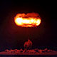

**Stokes**

19kt, Nevada Test Site, 7.Aug.1957

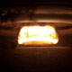

**Sunset**

20kt-1Mt, Christmas Island, 10.Jul.1962

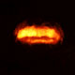

**Swanee**

20kt-1Mt, Christmas Island, 14.May.1962

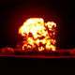

**Tesla**

7kt, Nevada Test Site, 1.Mar.1955

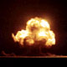

**Trinity**

21kt, New Mexico, 16.Jul.1945

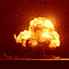

**Trinity**

21kt, New Mexico, 16.Jul.1945

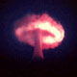

**Truckee**

20kt-1Mt, Christmas Island, 9.Jun.1962

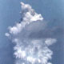

**Umbrella**

9kt, Eniwetok, 8.Jun.1958

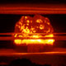

**Union**

6.9Mt, Bikini, 25.Apr.1954

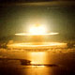

**Yeso**

>1Mt, Christmas Island, 10.Jun.1962

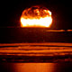

**Yeso**

>1Mt, Christmas Island, 10.Jun.1962

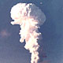

**Yukon**

20kt-1Mt, Christmas Island, 8.May.1962